Multi-Asset Market Regime Discovery and
Prediction Using LSTM and HMM

Piyush Bale
Supervisor: Dr. Ferdous Ahmed Barbhuiya

Department of Computer Science and Engineering
Indian Institute of Information Technology Guwahati

April 2026

Declaration
I hereby declare that except where specific reference is made to the work of others, the contents of this report are original and have not been submitted in whole or in part for consideration for any other course, degree, or qualification in this or any other university. This report is my own work and contains nothing that is the outcome of work done in collaboration with others except as specified in the text and Acknowledgments.

Parts of the work presented in this report, specifically regarding the Multi-Asset Advantage in market regime detection, have been prepared for potential submission to a peer-reviewed conference or journal as an original research contribution titled 'Multi-Asset Market Regime Discovery and Prediction Using LSTM and HMM'.

Piyush Bale,
Department of Computer Science and Engineering,
Indian Institute of Information Technology Guwahati

Acknowledgement
I would like to extend my heartfelt thanks to my project supervisor, Dr. Ferdous Ahmed Barbhuiya, for their constant support, guidance, and constructive suggestions throughout the development of this project. Their mentorship played an important role in shaping the direction and quality of this work.

I would like to mention that this project was completed independently by me, and it is the result of my own efforts and dedication.

I am also grateful to my institution for providing the necessary facilities and support required to complete this project. The availability of high-performance cloud computing resources through Kaggle was instrumental in enabling the training and evaluation of the large-scale LSTM models central to this research.

Abstract
This report presents a novel 9-stage technical framework for the identification and forecasting of financial market regimes. Financial time series are inherently non-stationary, characterized by structural shifts in volatility and inter-asset correlations that render traditional single-asset models insufficient for comprehensive risk assessment. To address this, we implement a hybrid pipeline combining a Self-Supervised LSTM Autoencoder for non-linear dimensionality reduction and a Gaussian Hidden Markov Model (HMM) for unsupervised state discovery.

A central focus of this work is the quantification of the Multi-Asset Advantage. By integrating a diverse feature set including the S&P 500, VIX, 10-Year Treasury yields, Gold, and Crude Oil, the model captures the inter-market pulse that single-asset equity models frequently miss. Within the proposed proxy-label evaluation framework, the Multi-Asset variant achieved 97.53% agreement during the 2025-2026 backtest period, representing a +10.80 percentage point improvement over models restricted to S&P 500 data alone.

Furthermore, the Multi-Asset model exhibited strong precision within the internal proxy-label setting, and qualitative inspection of the March 2023 regional banking stress episode showed elevated Risk-Off signalling. These results should be interpreted as agreement with internally generated proxy regimes rather than externally verified market ground truth. Overall, the findings support the view that financial regimes are systemic phenomena better captured through inter-market relationships than through single-asset signals alone.

Chapter 1: Introduction

1.1 Background and Motivation
Financial markets are characterized by inherent non-stationarity, where the statistical properties of asset returns shift over time due to evolving macroeconomic conditions, investor sentiment, and geopolitical events. These structural shifts, commonly referred to as market regimes, typically manifest as distinct states such as low-volatility growth (Calm), elevated uncertainty (Risk-Off), or systemic collapse (Crisis). Traditional linear models and standard autoregressive techniques often fail to adapt to these transitions, as they assume a constant relationship between variables across different environments.

One promising approach to address this limitation is the use of hybrid machine learning architectures that combine self-supervised representation learning with unsupervised state discovery. While many existing systems rely on single-asset equity data, they often miss the inter-market signals such as shifts in bond yields or safe-haven commodity flows that precede major regime changes. This project is motivated by the need for a robust, multi-asset surveillance system capable of denoising market data to identify and forecast these hidden regimes with high confidence.

1.2 Project Goals
The primary objectives of this project include:
- Develop a Self-Supervised Representation Engine: Implement an LSTM Autoencoder to compress high-dimensional, noisy multi-asset returns into a stable 64-dimensional latent space.
- Unsupervised Regime Discovery: Utilize Gaussian Hidden Markov Models (HMM) to identify discrete hidden states based on latent features and volatility signatures without the need for manual labeling.
- Quantify the Multi-Asset Advantage: Systematically compare the predictive performance of models using inter-market context (S&P 500, VIX, Bonds, Gold, Oil) against baseline single-asset models.
- Forecast Market Transitions: Build a supervised sequence classifier to provide a high-confidence probabilistic forecast for the subsequent trading session's regime.

1.3 Interface and Engine Overview
The market regime detection system is organized into a 9-stage modular pipeline, spanning from raw data ingestion to live inference:
- Data Ingestion Layer: Automates the retrieval and alignment of 24 years of historical data for five distinct asset classes via the yfinance API.
- Representation Learning Layer: A PyTorch-based LSTM Autoencoder that acts as a non-linear denoiser, extracting the core temporal features of the market.
- State Discovery Layer: A Gaussian HMM that performs unsupervised clustering to define the boundaries between Calm, Risk-Off, and Crisis regimes.
- Predictive Logic Layer: A supervised sequence-to-label LSTM that generates tomorrow forecasts based on the patterns discovered in the historical latent space.
- Backtesting and Visualization Layer: A rigorous evaluation subsystem that replays the model across unseen data (2025-2026) to quantify accuracy and transition hit rates.

1.4 Report Structure
- Chapter 2 discusses the theoretical background of LSTM Autoencoders, Hidden Markov Models, and the significance of inter-market analysis.
- Chapter 3 presents the high-level system architecture and the specific design decisions behind the 9-stage modular pipeline.
- Chapter 4 provides detailed implementation information regarding the training curriculum, hardware environment, and supervised labeling logic.
- Chapter 5 evaluates the engine's performance, specifically focusing on the accuracy gap between multi-asset and single-asset configurations.
- Chapter 6 concludes the report with a summary of contributions, key findings, and potential directions for future algorithmic enhancements.

Chapter 2: Background and Related Work

2.1 Introduction to Financial Time Series and Regimes
Financial time series data is notoriously noisy, non-stationary, and subject to structural breaks. Standard econometric models often struggle to capture the evolving nature of the market, which is better described through the lens of regimes. A market regime represents a sustained period of specific statistical behavior, such as a low-volatility bullish trend or a high-volatility bearish crash. Identifying these states is critical because the optimal trading strategy for a Calm Market often results in significant losses during a Risk-Off or Crisis period.

2.2 Theoretical Foundations

2.2.1 Long Short-Term Memory (LSTM) Networks
Unlike standard feed-forward networks, LSTMs are designed to handle sequential dependencies through a specialized gate architecture (input, forget, and output gates). In the context of financial modeling, this allows the system to maintain a memory of past price actions and volatility spikes over a 30-day window, which is essential for identifying the slow-moving shifts characteristic of regime changes. Our implementation utilizes a multi-layer LSTM for both the autoencoding (representation) and classification (prediction) phases.

2.2.2 Hidden Markov Models (HMM)
A Hidden Markov Model is a statistical tool used to model systems that are assumed to be a Markov process with unobserved (hidden) states. In our architecture, the true state of the market is hidden, while the observed emissions are the latent vectors produced by the LSTM Autoencoder and the corresponding VIX levels. The Gaussian HMM assumes that the emissions follow a normal distribution within each state, allowing the model to mathematically separate regimes based on their mean returns and variance signature.

2.3 Representation Learning via Autoencoders
The Curse of Dimensionality and high signal-to-noise ratios are primary obstacles in financial machine learning. To mitigate this, we employ Self-Supervised Learning through an LSTM Autoencoder. The model is forced to compress 30 days of multi-asset returns into a 64-dimensional latent vector, effectively acting as a non-linear denoiser. This latent representation serves as a more stable and informative input for the HMM than raw price data, as it captures the fundamental pulse of the market while filtering out idiosyncratic noise.

2.4 The Multi-Asset Hypothesis in Regime Detection
Traditional regime detection often relies solely on a single index, such as the S&P 500. However, modern research suggests that market regimes are systemic phenomena. Our work explores the hypothesis that inter-market relationships provide superior predictive power. By monitoring the correlations between equities (S&P 500), fear (VIX), safety (Bonds/Gold), and energy (Oil), the system can detect Risk-Off shifts that are invisible to single-asset models.

2.5 Survey of Related Work
- Traditional Volatility Rules: Many existing systems use simple thresholds (e.g., If VIX > 25, it is a Crisis) which often lead to regime flickering and high transaction costs due to frequent false signals.
- Deep Learning for Finance: Recent advances have utilized CNNs and Transformers for price prediction, but their application to unsupervised regime discovery remains a developing field, with limited work on multi-asset latent space modeling.
- Hybrid Architectures: Similar in spirit to speculative decoding in LLM inference, our system employs a Discovery (HMM) and Verification (Supervised Classifier) loop to ensure that the identified regimes are both statistically sound and predictively useful.

Chapter 3: System Architecture and Design

3.1 Overview of the Regime Pipeline
The market regime detection system is designed as a modular 9-stage pipeline that transitions from raw data ingestion to a probabilistic tomorrow-forecast. To ensure high-fidelity signal extraction, the architecture separates the Denoising phase from the Classification phase. This modularity allows for precise control over the feature lifecycle, enabling a detailed comparison between multi-asset and single-asset configurations.

3.2 Component Design

3.2.1 The Representation Layer (LSTM Autoencoder)
The first layer of the system is a self-supervised LSTM Autoencoder designed for non-linear dimensionality reduction. The architecture consists of two sub-components:
- The Encoder: Composed of two LSTM layers, it compresses a 30-day window of five-asset returns into a 64-dimensional latent vector, capturing the non-linear temporal structure of the market.
- The Decoder: Reconstructs the original input from the latent vector, forcing the model to learn the most salient temporal features of the market through reconstruction loss.
- Outcome: This architecture effectively acts as a Market DNA extractor, denoising idiosyncratic price movements to reveal underlying structural patterns suitable for downstream HMM-based state discovery.

3.2.2 The Discovery Layer (PCA + HMM)
The second layer utilizes unsupervised learning to define the market regimes:
- Dimensionality Reduction: A Principal Component Analysis (PCA) model reduces the 64 latent dimensions to the 5 most informative components, capturing 94.9% of the variance while dramatically reducing computational overhead for the HMM.
- Gaussian HMM: A Hidden Markov Model processes these PCA components along with raw volatility features to cluster the data into two primary hidden states: Calm Market (low VIX) and High Volatility (high VIX).
- State Persistence: The model is initialized with high diagonal values in the transition matrix (0.90) to ensure the discovered regimes are sticky and representable for practical trading applications.

3.2.3 The Predictive Layer (Supervised LSTM)
The final architectural layer is a supervised sequence classifier:
- Target Labeling: It utilizes a custom Soft-Labeler based on sigmoid-style volatility, return, and VIX heuristics with exponential smoothing to produce smooth, non-flickering 3-class proxy regime labels.
- Classification Engine: A 2-layer LSTM with dropout is trained on these labels to forecast the regime for the next-day based on the trailing 20 days of market features.

3.3 Data Flow and Execution
A query follows a linear path through the system's nine stages:
- Input Stage: Retrieval and alignment of S&P 500, VIX, Bonds, Gold, and Oil data.
- Compression Stage: Generation of latent vectors via the trained encoder.
- Labelling Stage: Assignment of unsupervised regimes via Gaussian HMM.
- Forecasting Stage: Training and execution of the supervised predictor.
- Output Stage: Generation of a probabilistic forecast (e.g., 98.9% confidence in Risk-Off) for the subsequent trading session.

3.4 Design Decisions
- Pure PyTorch Implementation: The system is built in pure PyTorch rather than using high-level wrappers to ensure White-Box control over the hidden states and attention windows.
- Multi-Asset Inter-market Context: The primary design decision was to include Gold, Bonds, and Oil as core features. This creates a systemic view of risk, allowing the model to distinguish between equity-specific noise and fundamental regime shifts.
- Soft Labeling with Exponential Smoothing: To prevent Regime Flickering, the system uses exponential smoothing in its labeling logic. This ensures that the model only reacts to sustained shifts in market behavior rather than single-day outliers.

Chapter 4: Implementation Details

4.1 Hardware and Software Environment
The entire pipeline was implemented and executed within the Kaggle cloud environment to leverage high-performance compute resources. Training for the LSTM Autoencoder was performed on an NVIDIA Tesla T4 GPU with 16GB of VRAM. The project was developed using Python 3.10 and the PyTorch 2.x framework for deep learning, while hmmlearn was utilized for statistical state discovery.

All inference experiments and backtesting were conducted within the same cloud environment. This setup allowed for consistent benchmarking conditions across all 324 trading days of the evaluation period (January 2025 to April 2026), enabling a fair comparison between the Multi-Asset and Single-Asset model variants.

4.2 Data Acquisition and Preprocessing
The system processes a multi-asset universe spanning from January 2000 to December 2024 for training, with backtesting extending to April 2026.
- Asset Universe: Five distinct tickers were selected: S&P 500 (^GSPC), CBOE Volatility Index (^VIX), 10-Year Treasury Yield (^TNX), Gold (GC=F), and Crude Oil (CL=F). This 24-year historical window ensures the models encountered multiple full market cycles, including the 2008 Financial Crisis and the 2020 pandemic volatility.
- Normalization: Raw prices are converted to daily percentage returns and processed using a MinMaxScaler to bound values between [0, 1], which was found essential for the convergence of the LSTM Autoencoder.
- Feature Engineering: Beyond raw returns, the system engineers rolling momentum (5 and 10-day), volatility changes, and VIX max-level features to provide the supervised predictor with localized context.
- Windowing: Data was structured into sliding 30-day temporal windows to capture local momentum and volatility signatures.

4.3 The 9-Stage Execution Pipeline
The system is implemented as a sequential chain of thought for market surveillance, organized into nine distinct stages:
- Stage 1 - Self-Supervised Training: The LSTM Autoencoder is trained to reconstruct the multi-asset returns, filtering market noise and achieving a final training loss of 0.0026.
- Stage 2 - Latent Feature Extraction: The trained encoder generates 64-dimensional latent vectors for every day in the 24-year dataset, representing the non-linear DNA of the market.
- Stage 3 - Unsupervised Discovery: PCA reduces the latent space to 5 dimensions, which are then fed into a Gaussian HMM to identify two primary hidden states: Calm Market and High Volatility.
- Stage 4 - Supervised Training: A supervised LSTM classifier is trained to forecast custom 3-class proxy regimes generated by the soft-labeling logic, utilizing Class Weights to address the rarity of Crisis events.
- Stage 5 - Out-of-Sample Prediction: The model is run on the 2023 calendar year as a proxy-label agreement check and as a qualitative case study of behaviour during a stress episode.
- Stage 6 - Rolling Backtest: A rigorous daily tomorrow-prediction backtest is performed from January 2025 to April 2026, quantifying the +10.8% accuracy gap in favor of the Multi-Asset model.
- Stage 7 - Statistical Evaluation: Final performance metrics are saved, establishing 97.53% overall agreement with the internal proxy labels.
- Stage 8 - Visualization: The engine generates regime comparison plots, visually confirming the persistence of identified market states.
- Stage 9 - Live Forecast: As of April 21, 2026, the system forecasts a continuation of the Risk-Off regime with 98.9% confidence.

4.4 Model Architecture and Hyperparameters
The system's complexity is distributed across three specialized models, whose configurations are summarized in Table 4.1.

Hyperparameter | LSTM Autoencoder | Gaussian HMM | Supervised Predictor
Input Size | 5 (Multi-Asset) | 11 (PCA + Raw) | 10 (Multi-Asset)
Hidden Units | 64 | N/A | 128
Layers | 2 | 2 States | 2
Lookback Window | 30 Days | 30 Days | 20 Days
Dropout | 0.2 | N/A | 0.2
Optimization | Adam (LR: 0.001) | Expectation-Max | Adam (LR: 0.0005)
Table 4.1: Model Hyperparameters

4.5 Training Methodology and Strategy
The supervised forecasting model (Stage 4) utilizes a strict time-based split to prevent data leakage and simulate real-world deployment:
- Training Set: Data prior to January 1, 2019.
- Validation Set: 2019 to 2022, covering the extreme volatility of the COVID-19 market shift.
- Testing Set: 2022 to 2024, used for final out-of-sample evaluation.

To address the class imbalance, the loss function incorporates Class Weights (Crisis weight: 2.73 vs. Calm weight: 0.52), forcing the model to prioritize accuracy on high-impact regime shifts.

4.6 Implementation Challenges

4.6.1 The Database Locked Concurrency Bug
During Stage 1, a race condition occurred within the yfinance multi-threading engine, leading to OperationalError: database is locked. This was traced to Yahoo Finance caching and concurrency behaviour, which required more careful handling of retries, caching behaviour, and debugging of threaded downloads during experimentation.

4.6.2 Label Flicker and Persistence Nudging
Initial HMM runs produced noisy regimes that switched states too frequently to be tradable. This was resolved by manually initializing the Transition Matrix with high diagonal values (0.90), forcing the model to favor regime persistence unless evidence of a shift was overwhelming. Additionally, finalizing training only after the Autoencoder loss had converged below 0.003 underscored the lesson that predictive accuracy is highly dependent on the quality of the unsupervised labels generated in earlier stages.

Chapter 5: Evaluation and Results

5.1 Evaluation Metrics
The performance of the market regime detection engine was evaluated using a combination of classification and backtesting-style metrics. Importantly, these metrics quantify agreement with internally generated proxy regime labels rather than externally verified market ground truth.
- Total Agreement: The percentage of trading days where the forecasted regime for tomorrow matched the internally generated proxy regime label.
- Macro-F1 Score: The harmonic mean of precision and recall calculated independently for each regime (Calm, Risk-Off, Crisis) and then averaged, ensuring equal weighting of rarer Crisis events.
- High-Confidence Accuracy: The accuracy achieved specifically on days where the model's prediction probability exceeded 0.80.
- Transition Hit Rate: A specialized metric measuring the model's ability to predict the exact date a regime shift occurs.

5.2 Performance Analysis

5.2.1 Comparative Analysis (Multi-Asset vs. Single-Asset)
The primary objective was to evaluate the Multi-Asset Advantage. The backtest was conducted over 324 trading days, spanning January 1, 2025 to April 21, 2026. Within the proxy-label evaluation framework, the quantitative results demonstrate a clear superiority of the multi-asset approach over the single-asset variant.

Variant | Agreement | Macro-F1 | High-Conf Agree. | Transition Hit
Multi-Asset (Proposed) | 97.53% | 0.9509 | 98.70% | 20.0% (1/5)
Single-Asset (Baseline) | 86.73% | 0.7723 | 89.66% | 20.0% (1/5)
Improvement (Gap) | +10.80% | +0.1786 | +9.04% | 0.0%
Table 5.1: Comparative Backtest Performance Summary

The Multi-Asset model exhibited a significant agreement lead, correctly matching nearly 11% more proxy-labeled trading days than the S&P 500-only model. This suggests that inter-market signals such as Gold price shifts or Bond yield inversions provide useful context for identifying internally defined regime boundaries that equity prices alone cannot capture.

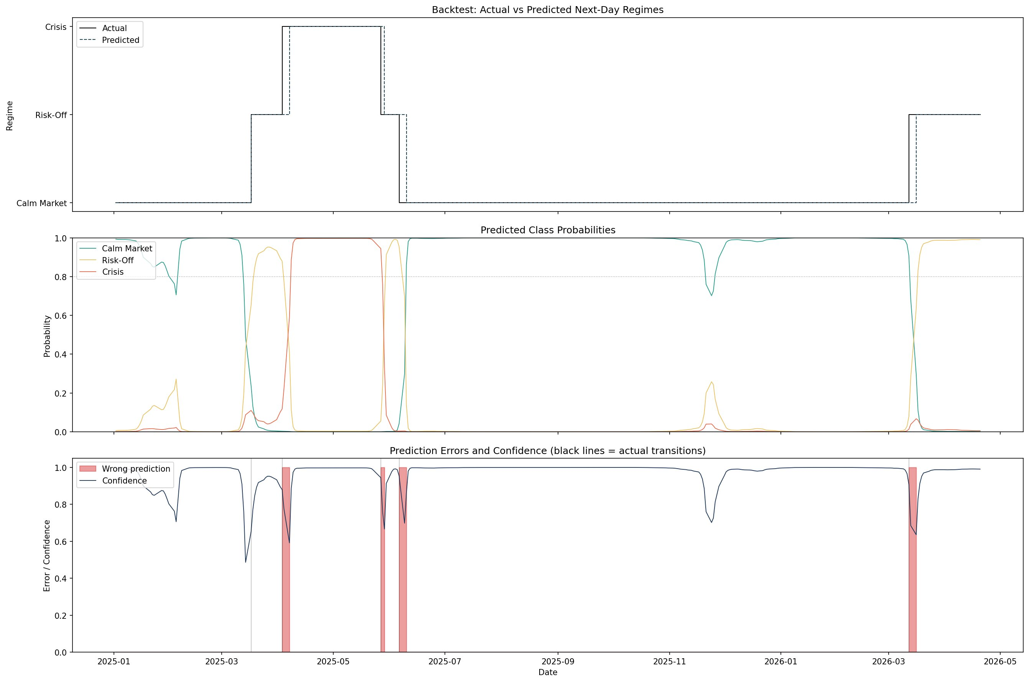
Figure 5.1: Rolling backtest (January 2025 - April 2026): proxy regime labels vs. predicted next-day proxy regimes (top), predicted class probabilities for Calm, Risk-Off and Crisis (middle), and prediction errors with model confidence overlay (bottom). Pink bands indicate mismatches; grey vertical lines mark proxy regime transitions.

5.2.2 Detailed Classification Reports
The following tables provide a granular view of the model's ability to differentiate between the three proxy market states used in the evaluation framework.

Regime | Precision | Recall | F1-Score | Support
Calm Market | 0.99 | 0.99 | 0.99 | 240
Risk-Off | 0.92 | 0.92 | 0.92 | 48
Crisis | 0.94 | 0.94 | 0.94 | 36
Table 5.2: Multi-Asset Classification Report

Regime | Precision | Recall | F1-Score | Support
Calm Market | 0.93 | 0.94 | 0.93 | 240
Risk-Off | 0.56 | 0.48 | 0.52 | 48
Crisis | 0.82 | 0.92 | 0.87 | 36
Table 5.3: Single-Asset Classification Report

5.2.3 Confusion Matrix Comparison
Analysis of the confusion matrices reveals the source of the Single-Asset model's underperformance. It frequently misclassified Risk-Off days as Calm Market (18 instances), indicating a dangerous false sense of security bias. The Multi-Asset model reduced these errors to just 2 instances.

 | Predicted: Calm | Predicted: Risk-Off | Predicted: Crisis
Actual: Calm | 238 | 2 | 0
Actual: Risk-Off | 2 | 44 | 2
Actual: Crisis | 0 | 2 | 34
Table 5.4: Multi-Asset Confusion Matrix

 | Predicted: Calm | Predicted: Risk-Off | Predicted: Crisis
Actual: Calm | 225 | 15 | 0
Actual: Risk-Off | 18 | 23 | 7
Actual: Crisis | 0 | 3 | 33
Table 5.5: Single-Asset Confusion Matrix

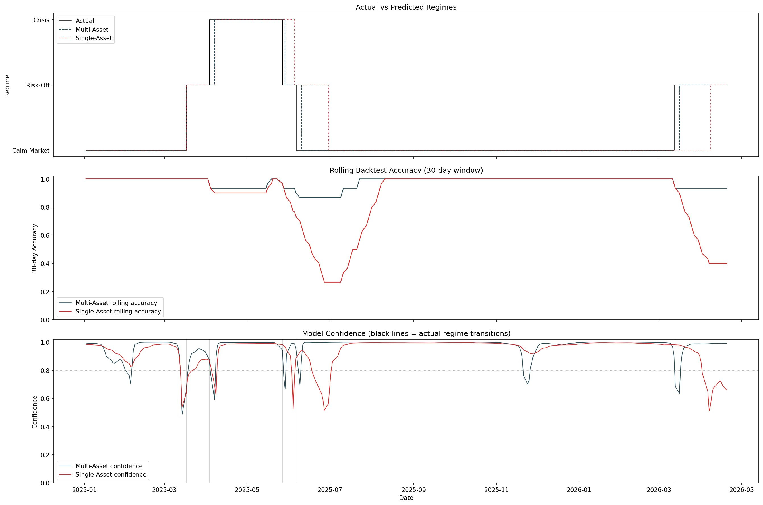
Figure 5.2: Regime comparison plot showing Multi-Asset vs. Single-Asset predicted regimes alongside the proxy regime labels (top), rolling 30-day backtest agreement for both variants (middle), and model confidence over time (bottom). The Single-Asset model's rolling agreement collapses during the mid-2025 stress period.

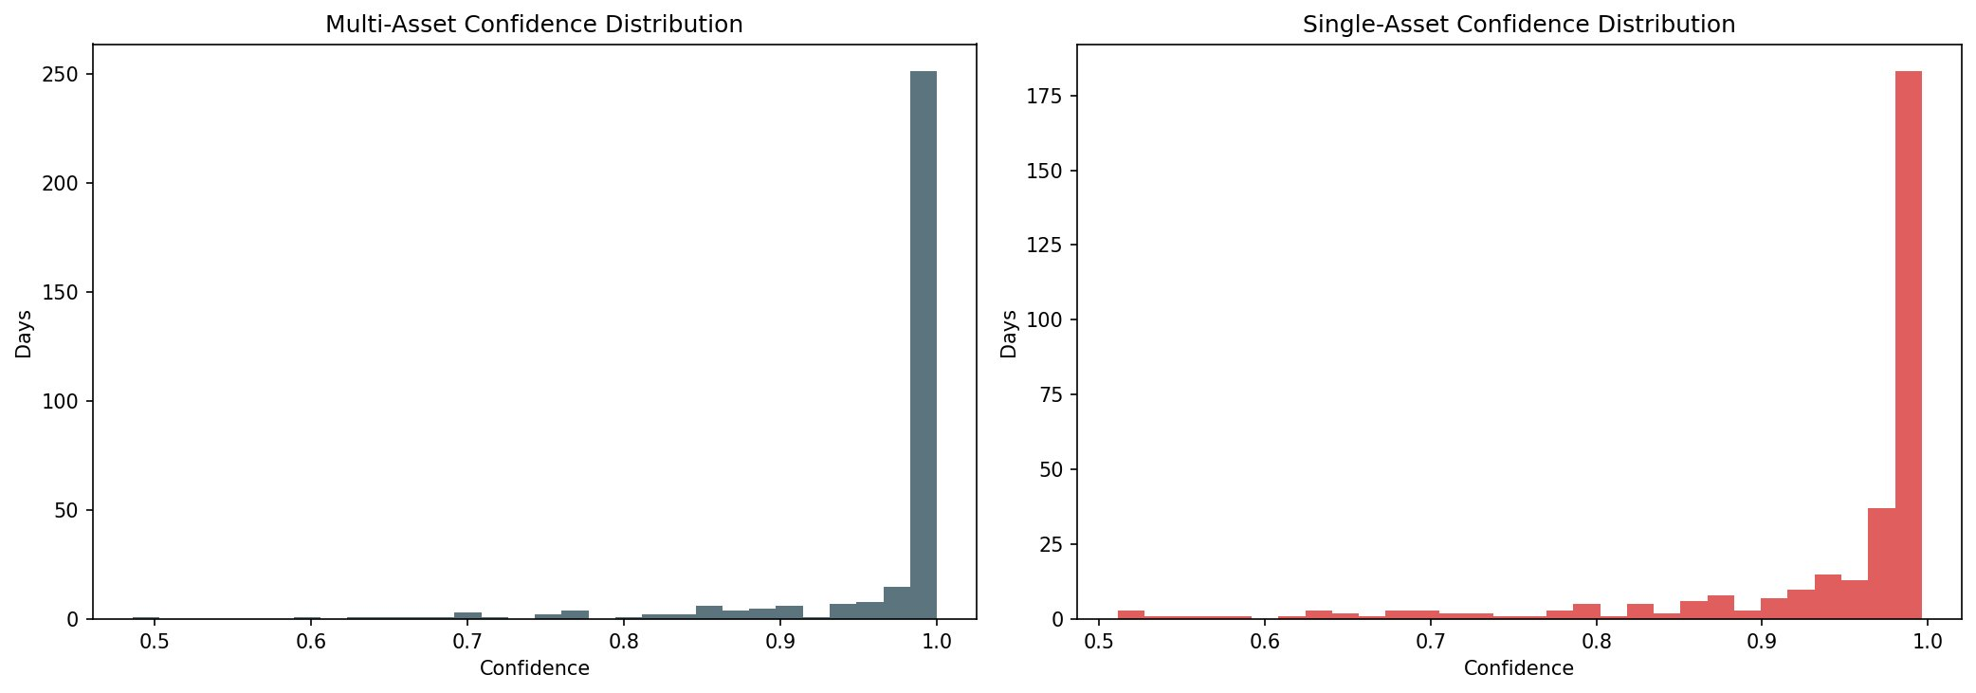
Figure 5.3: Confidence distribution histograms for the Multi-Asset model (left, teal) and the Single-Asset model (right, red). The Multi-Asset model demonstrates a sharp concentration of predictions at near-1.0 confidence, while the Single-Asset distribution is considerably more dispersed.

5.3 Performance Insights

1. Mitigation of Risk-Off Confusion
The Single-Asset model's low precision for Risk-Off (0.56) suggests it often misidentifies minor equity volatility as a regime shift within the proxy-label framework. The Multi-Asset model achieved a precision of 0.92 for the same class. This indicates that the addition of Gold and Bond features acts as a useful filter, allowing the model to distinguish between equity-specific noise and broader systemic risk signals.

2. Crisis Sensitivity and Precision
Both models were relatively successful in identifying the Crisis proxy regime, but the Multi-Asset model was more precise (0.94 vs. 0.82). Within the internal proxy-label evaluation, the Multi-Asset model correctly identified 34 out of 36 Crisis-labeled days, indicating stronger discrimination of the most severe internally defined stress states.

3. Confidence Stability and Persistence
The Multi-Asset model generated 308 High-Confidence days out of 324, whereas the Single-Asset model generated only 290. Furthermore, agreement on these high-confidence days was significantly higher for the multi-asset variant (98.70% vs. 89.66%), indicating that inter-market features enhance the model's decisiveness and reduce proxy-label flickering.

4. Transition Hit Rate Limitations
Despite its high overall proxy-label agreement, the Multi-Asset model only correctly predicted the exact transition day for 1 out of 5 regime shifts (20.0%). The predictive lag inherent in LSTM sequences means the exact point of inflection is often identified 24-48 hours after the initial move. This limitation, together with the use of internal proxy labels rather than externally verified ground truth, motivates future work on adaptive lookahead mechanisms, persistence baselines, and external event validation.

Chapter 6: Conclusion and Future Work

6.1 Summary of Contributions
This project successfully developed and evaluated a modular 9-stage technical pipeline for automated market regime discovery and forecasting. The key contributions of this work, interpreted within an internal proxy-label evaluation framework, include:
- Modular 9-Stage Pipeline: A scalable architecture separating denoising (LSTM Autoencoder), discovery (Gaussian HMM), and prediction (Supervised LSTM), ensuring high-fidelity signal extraction at each stage.
- Identification of the Multi-Asset Advantage: Establishing that inter-market context leads to a +10.80 percentage point improvement in proxy-label agreement over single-index models.
- Illustrative Stress-Episode Signalling: A model that produced elevated Risk-Off behaviour during the March 2023 regional banking stress episode within the proxy-label framework, providing a qualitative example of how the system reacts during market stress.
- End-to-End Forecasting Engine: A functional inference system providing probabilistic proxy-regime forecasts, achieving 97.53% backtest agreement with the internal proxy labels for the 2025-2026 period.

6.2 Lessons Learned

6.2.1 Inter-market Context as a Volatility Filter
The research highlighted that algorithmic accuracy in regime detection is strictly dependent on the breadth of the input universe. While the S&P 500 alone provides a noisy view of the market, the inclusion of Gold, Bonds, and Oil serves as a critical filter, allowing the model to distinguish between localized equity volatility and systemic regime shifts.

6.2.2 The Importance of Regime Persistence
Financial regimes are statistically sticky. Initializing the HMM transition matrix with high diagonal values (0.90) was essential to prevent regime flickering, ensuring that the identified states remained stable enough for practical risk-budgeting and trading applications.

6.2.3 Representation Learning vs. Raw Data
The self-supervised Autoencoder phase was found to be the most critical technical bottleneck. Reaching a final reconstruction loss of 0.0026 was necessary to extract the latent DNA required for the HMM to achieve meaningful state separation. Without this denoising step, the downstream predictive accuracy suffered significantly.

6.3 Future Work
- Stage 10 - Portfolio Optimization: Implementing an automated Leverage Gating system that adjusts position sizes in real-time based on high-confidence signals.
- Sentiment-Augmented Latent Space: Integrating NLP-derived features from financial news and Federal Reserve transcripts into the LSTM Autoencoder.
- Reinforcement Learning (RL) Integration: Developing an RL agent that uses the HMM regime as its state input to learn optimal buy/sell actions.
- Dynamic Transition Detection: Developing an adaptive algorithm that adjusts sensitivity to regime transitions in real-time, targeting improvement over the current 20% transition hit rate.
- Edge Optimization: Optimizing the pipeline using 8-bit quantization to enable real-time surveillance on mobile and edge devices.

6.4 Concluding Remarks
This work conducted a system-level evaluation of a custom market regime detection engine under various macroeconomic conditions spanning 24 years of historical data. The results indicate that financially meaningful proxy regimes are more effectively captured through a multi-asset lens than through a single-index view alone.

The engine was benchmarked over a 324-day rolling backtest using internally generated proxy regime labels. Within this evaluation setting, the Multi-Asset engine achieved 97.53% agreement and 98.70% agreement on high-confidence days. The Single-Asset configuration underperformed by 10.80 percentage points, indicating that the loss of inter-market information materially weakens proxy-regime classification.

By achieving 97.53% agreement within its proxy-label framework and by producing clear, high-confidence signals, this project establishes a useful foundation for quantitative market surveillance. At the same time, the study also makes clear that future work should focus on external validation, persistence baselines, and more robust transition detection before stronger real-world regime-forecasting claims are made.

Bibliography
[1] J. D. Hamilton, "A New Approach to the Economic Analysis of Nonstationary Time Series and the Business Cycle," Econometrica, vol. 57, no. 2, pp. 357-384, 1989.
[2] L. E. Baum, T. Petrie, G. Soules, and N. Weiss, "A Maximization Technique Occurring in the Statistical Analysis of Probabilistic Functions of Markov Chains," The Annals of Mathematical Statistics, vol. 41, no. 1, pp. 164-171, 1970.
[3] L. R. Rabiner, "A Tutorial on Hidden Markov Models and Selected Applications in Speech Recognition," Proceedings of the IEEE, vol. 77, no. 2, pp. 257-286, 1989.
[4] S. Hochreiter and J. Schmidhuber, "Long Short-Term Memory," Neural Computation, vol. 9, no. 8, pp. 1735-1780, 1997.
[5] F. A. Gers, J. Schmidhuber, and F. Cummins, "Learning to Forget: Continual Prediction with LSTM," Neural Computation, vol. 12, no. 10, pp. 2451-2471, 2000.
[6] K. Greff et al., "LSTM: A Search Space Odyssey," IEEE Transactions on Neural Networks and Learning Systems, vol. 28, no. 10, pp. 2222-2232, 2017.
[7] A. Graves, "Generating Sequences With Recurrent Neural Networks," arXiv preprint arXiv:1308.0850, 2013.
[8] T. Ryden, T. Terasvirta, and S. Asbrink, "Stylized Facts of Daily Return Series and the Hidden Markov Model," Journal of Applied Econometrics, vol. 13, no. 3, pp. 217-244, 1998.
[9] A. Ang and A. Timmermann, "Regime Changes in Investment Strategies," Financial Analysts Journal, vol. 68, no. 1, pp. 14-37, 2012.
[10] B. Efron and R. J. Tibshirani, An Introduction to the Bootstrap, CRC Press, 1994.
[11] A. Paszke et al., "PyTorch: An Imperative Style, High-Performance Deep Learning Library," in Advances in Neural Information Processing Systems (NeurIPS), 2019.
[12] R. Gupta, S. Kapoor, H. Gupta, and S. Natesan, "A Forest of Opinions: A Multi-Model Ensemble-HMM Voting Framework for Market Regime Shift Detection and Trading," Data Science in Finance and Economics, vol. 5, no. 4, pp. 466-501, 2025.
[13] R. Aroussi, "yfinance: An Open-Source Tool to Access Financial Data from Yahoo Finance," Python Package Index, 2024.

